EXPERIMENT 1
DDL COMMANDS-Creat,Alter,Drop
I,JASWANTH
192525345
AIML
CSA0503

1.
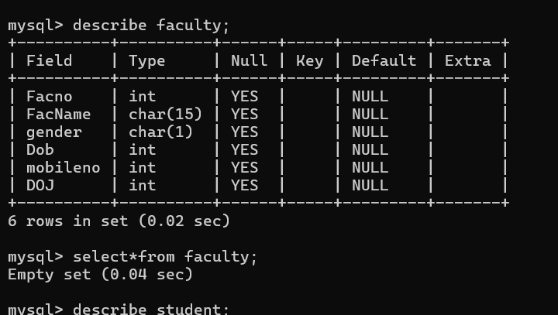
2.
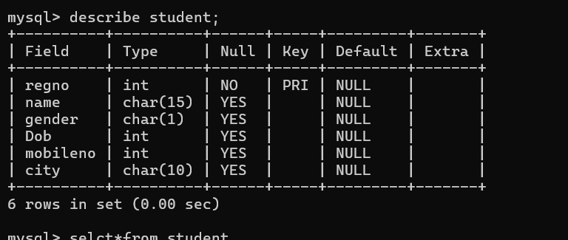
3.
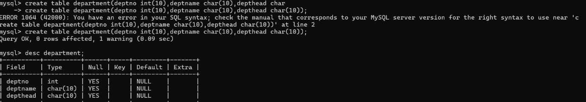
4.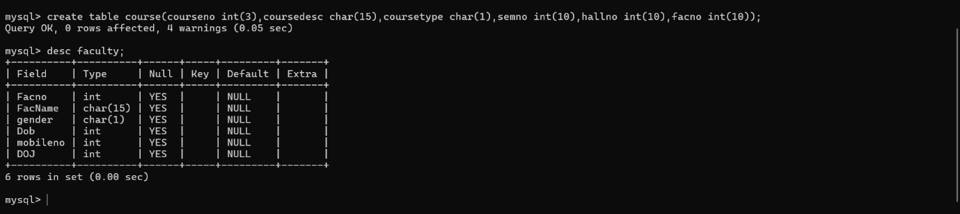
5.